A HYBRID ARTIFICIAL INTELLIGENCE-BASED ERP PROCUREMENT RISK SCORING AND APPROVAL ORCHESTRATION SYSTEM
Throughput
Abstract:
The present invention generally describes an enterprise resource planning procurement intelligence system, which is specifically designed and configured to be integrated with SAP systems and generate hybrid artificial intelligence-based risk scoring for purchase requisitions. The system is designed and configured as an advisory decision-support system and does not alter ERP transactional data without approval authorization.
The system includes:
- An ERP data ingestion module
- Deterministic rule-based risk constraint engine
- A probabilistic risk engine using machine learning
- A hybrid fusion scoring engine
- A disruption monitoring and re-evaluation module
- An explainable advisory generation module
- A workflow orchestration and logging module
The system uses a weighted fusion model to calculate hybrid procurement risk scores and provide explainable advisory outputs to aid enterprise approval processes, ensuring auditability and decision authority.
Description:
Background of the Invention:
In corporate procurement systems, purchase requisitions (PRs) are normally assessed based on:
- Static rule-based validation logic
- Manual managerial review
- Predefined approval hierarchies

These methods can lead to:
- Inconsistent risk evaluation
- Delays in approvals
- Budget overruns
- Supplier risk exposure
- Limited explainability in audit trails
Conventional ERP systems handle transactional data but lack hybrid artificial intelligence explainable risk scoring integrated with workflow orchestration.
A need exists for a system that can:
- Integrate deterministic compliance logic with probabilistic machine learning risk inference
- Produce explainable risk scores
- Dynamically route approvals for computed risk
- Maintain ERP system control without modifying financial data directly
Summary of the Invention:
It is an object of the present invention to provide a hybrid artificial intelligence-based ERP procurement risk evaluation and approval orchestration system.
The system includes:
ERP Data Ingestion Module (100):
Designed to fetch purchase requisition data from SAP S/4HANA using OData APIs.
Rule-Based Risk Constraint Engine (200):
Designed to calculate deterministic compliance risk scores based on:
- Budget thresholds
- Quantity anomalies
- Supplier flags
- Policy violations

Hybrid AI Engine (300):
Designed to integrate deterministic and probabilistic risk scores using:
Rx =αR1 +βR2
Where:
- R1 = Deterministic rule-based score
- R2 = Machine learning probability score
- Rx = Final hybrid risk score
- α,β = Configurable weighting coefficients
Disruption Monitoring & Re-Evaluation Module (400):
Designed to monitor changes in procurement parameters and initiate real-time re-scoring.
Advisory Coordination & Workflow Module (500):
Designed to:
- Produce interpretable risk advisories
- Dynamically route requisitions
- Escalate high-risk requisitions
- Record advisory rationale for audit purposes
The system is designed to strictly function in an advisory role and does not independently perform ERP financial postings.
Brief Description of the Drawings:
FIG. 1 – Overall Hybrid ERP Procurement Intelligence System Architecture
FIG. 2 – Hybrid AI Risk Scoring Engine Architecture
FIG. 3 – Real-Time Risk Re-Evaluation and Disruption Handling Flow
FIG. 4 – Advisory Coordination and Approval Workflow Mechanism
DESCRIPTION OF PREFERRED EMBODIMENT
With reference to the accompanying drawings and in particular to FIGS. 1 to 4, the preferred embodiment of the present invention is described in detail hereinafter.
FIG. 1 – Overall System Architecture
From FIG. 1, the system consists of:
- Data Ingestion Module (100)
- Rule Constraint Engine (200)
- Hybrid AI Engine (300)
- Disruption Monitoring Module (400)
- Advisory Coordination Module (500)
The Data Ingestion Module (100) fetches the following fields from the purchase requisition:
- Purchase Requisition
- Material
- Requested Quantity
- Purchase Requisition Price
- Item Net Amount
- Supplier
- Plant
- Company Code
- Delivery Date
- Processing Status
The Rule Constraint Engine (200) determines deterministic compliance risk.
The Hybrid AI Engine (300) calculates the final hybrid risk score.
The Advisory Coordination Module (500) produces interpretable approval suggestions and records justification.
FIG. 2 – Hybrid AI Risk Scoring Engine
Referring to FIG. 2, the Hybrid AI Engine (300) includes:
- Rule-Based Risk Module (310)
- Machine Learning Risk Module (320)
- Fusion Engine (330)
- Explainability Generator (340)
The Rule-Based Risk Module (310) generates deterministic risk score R1.
The Machine Learning Risk Module (320) generates probabilistic risk output R2 using:
- Logistic regression and/or
- Random forest models
- Feature encoding of supplier history, budget usage, quantity variance
The Fusion Engine (330) computes:
Rx=αR1+βR2
The Explainability Generator (340) translates calculated factors into structured human-readable rationale.
FIG. 3 – Real-Time Risk Re-Evaluation Flow
Referring to FIG. 3, the Disruption Monitoring Module (400) carries out the following tasks:
- Update detection of new ERP records
- Encoding of new operational constraints
- Re-computation of hybrid risk score
- Output of new advisory decision
Triggering conditions include:
- Budget update
- Update of supplier risk flag
- Update of quantity
- Update of delivery date
The system ensures risk score consistency under dynamic procurement changes.
FIG. 4 – Coordinated Dual-End Advisory Generation
Referring to FIG. 4, the Advisory Coordination Module (500) consists of:
- Dispatch Advisory Generator (510)
- Approval Receiver Interface (520)
- Advisory Consistency Validator (530)
- Advisory Log Storage (540)
The module guarantees:
- Risk-based routing
- Escalation of high-risk requisitions
- Auto-approval of low-risk requisitions
- Recording of risk explanation in database field risk_explanation
All advisory decisions are recorded for audit traceability.
Claims:
- A hybrid artificial intelligence-based ERP procurement risk evaluation system comprising:
- Data ingestion module designed to extract purchase requisition data from SAP systems;
- A deterministic rule-based risk scoring engine
- A machine learning-based probabilistic risk engine
- A hybrid fusion engine calculating a final risk score
- An explainable advisory generation module
- A workflow orchestration module for risk-based approval routing.

- The system as claimed in claim 1, wherein the hybrid fusion score is calculated as:
Rx =αR1 +βR2
- The system as claimed in claim 1, wherein the advisory outputs comprise recorded rationale stored for audit traceability.
- The system as claimed in claim 1, wherein high-risk requisitions are dynamically escalated to multi-level approval workflows.
- The system as claimed in claim 1, wherein the system integrates with SAP S/4HANA via OData APIs.
- The system as claimed in claim 1, wherein the system operates in advisory mode without directly executing financial postings in the ERP system.

Figures
Fig 1
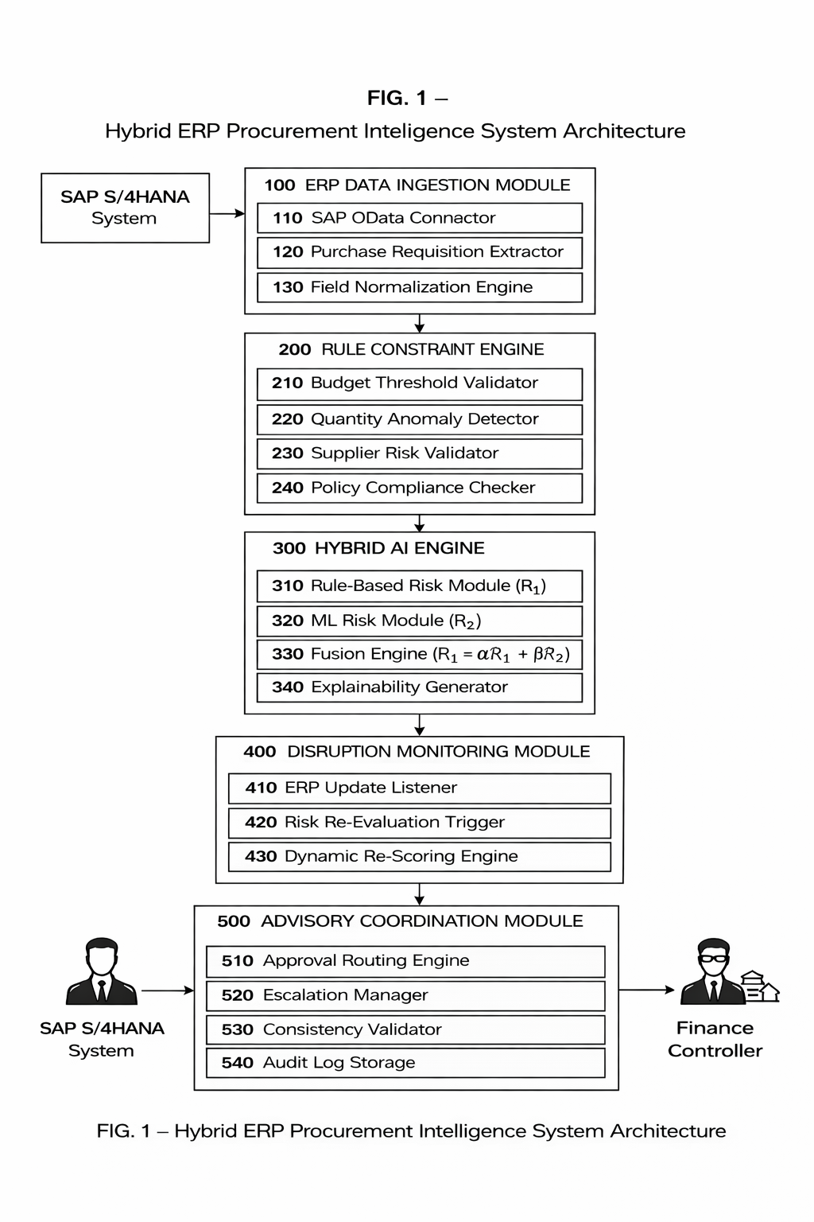
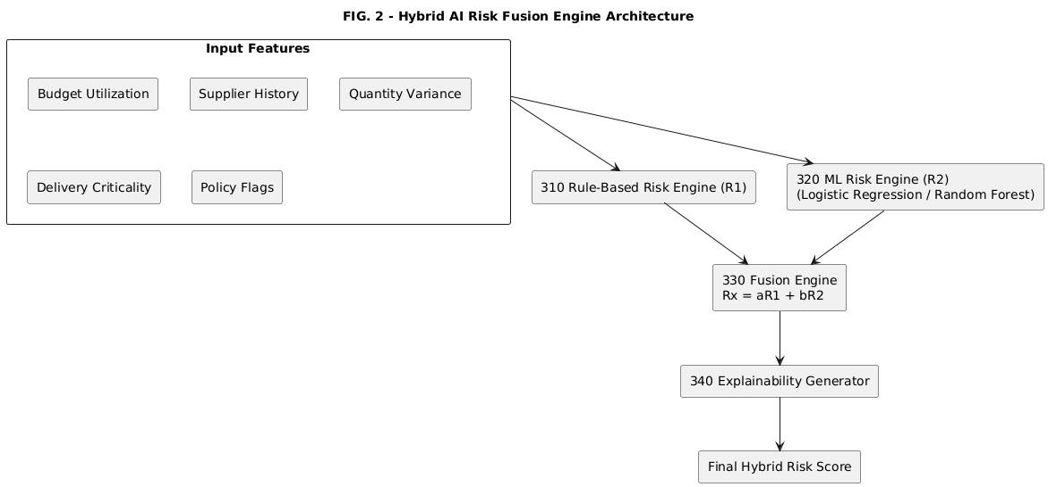
Fig 2

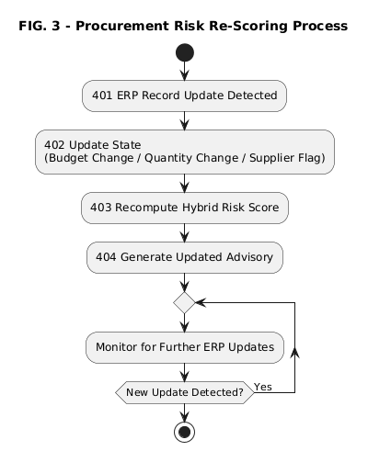
Fig 3

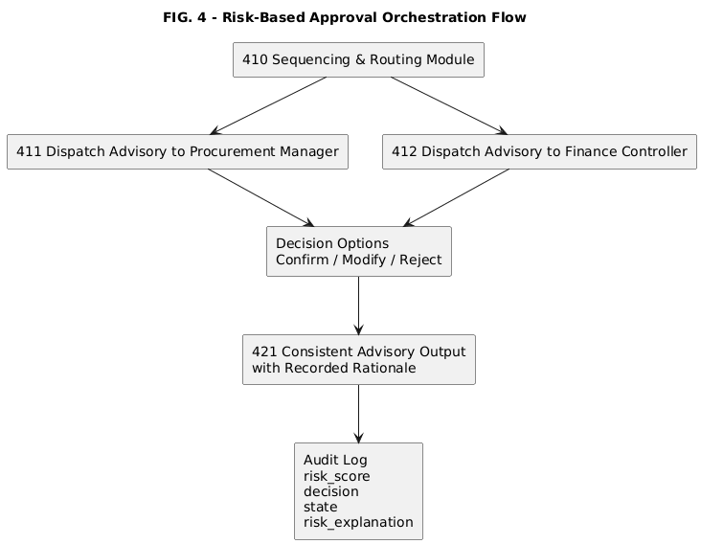
Fig 4

